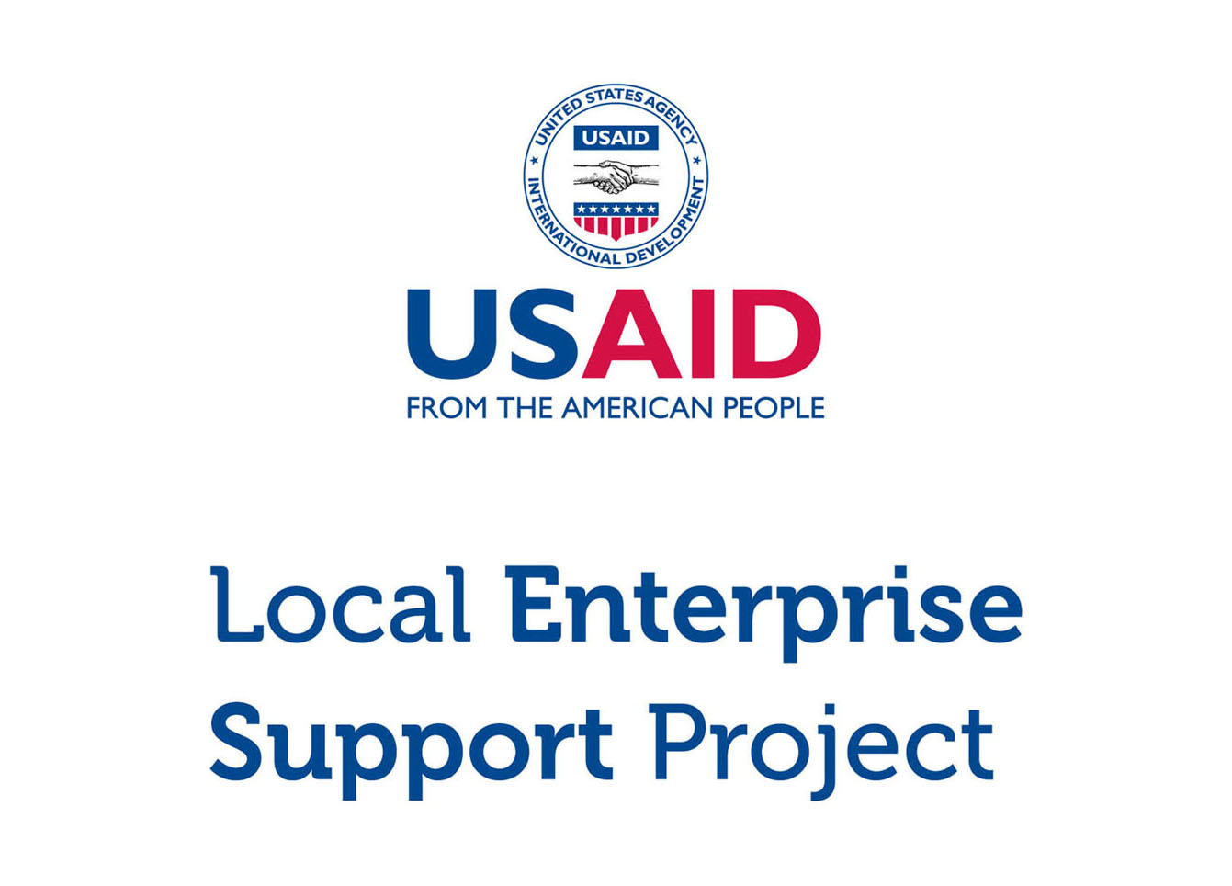

**Micro and Small Enterprise (MSE) Survey**

Results for Aqaba Governorate

Tuesday, March 15, 2016

**DISCLAIMER**

The USAID Jordan Local Enterprise Support (LENS) Project is funded by the United States Agency for International Development (USAID) and implemented by FHI 360. This report is made possible by the generous support of the American people through the United States Agency for International Development (USAID). The contents are the responsibility of FHI 360 and do not necessarily reflect the views of USAID or the United States Government.

**ACKNOWLEDGEMENTS**

This report was written by Bryanna Millis and Rafael Pilliard-Hellwig, with contributions from Faisal Awartani, Muin Khoury, Edmund Morris, and Jonathan Peters. The report was translated by Dania Mousa and Shadi Al Rawashdeh.

# Highlights

|  |  |  |
| --- | --- | --- |
| 715  MSEs |  | MSES ARE THE MAJORITY > There are an estimated 715 micro and small enterprises in Aqaba. Nine in ten MSEs are single-person businesses, and roughly two thirds operate in retail and trade. |
|  |  |  |
| 8% WOMEN |  | MSES ARE MALE-DOMINATED > Only 8.3% of Aqaba’s MSEs are woman-owned. Women who have MSEs are more likely than men to earn less, to operate out home locations, and to work out of necessity. |
|  |  |  |
| 5/10  ARE REGISTERED |  | MSES EXIST ON PAPER > Despite the fact that most MSEs do not pay tax and few have employees, 50.4% are nonetheless registered with the Ministry of Industry and Trade. |
|  |  |  |
| 7 YEARS  IN EXISTENCE |  | MSES ARE NACENT > The typical MSE has been in business for seven years. 90.9% of businesses in Aqaba believe they will continue to operate for at least 3 years. |
|  |  |  |
| 200 JD  PROFIT |  | MSES STRUGGLE TO GET BY > MSEs that make profit report a median bottom line of 200 JD per month (usually excluding the MSE owner’s own salary). 69.9% of MSEs are losing money or struggling to live comfortably. |
|  |  |  |
| 4% USE  COMPUTERS |  | MSES ARE DIGITALLY ABSENT > Only 4.2% of businesses use a computer in the course of their work. 4.2% uses social media either for work or personal purposes. |
|  |  |  |
| <10%  PENETRATION |  | MSES LACK COLLECTIVE POWER > Memberships in associations are weak. With this exception of the chambers, the penetration rate for trade associations, business groups, and cooperatives is below 10%. |

Table of Contents

Introduction 5

General Demographics 6

Contracts 18

Workforce 19

Firm Performance 23

Access to Finance 26

Systems, Processes and Networks 29

Policy and Regulations 33

Data was compiled using data file “**new_lens_usa_fix_pswt.sav**” (MD5 hash: 3958a9180d)

# Introduction

## About USAID LENS

The USAID Jordan Local Enterprise Support Project (LENS) is a five-year project to encourage the long-term economic growth and development potential of underserved Jordanian communities. USAID LENS combines local economic development with private sector development initiatives to help create jobs and sustainable growth that is inclusive of women and youth.

LENS’ systemic approach to local economic development is meant to catalyze inclusive local and regional economic networks in a business-enabling environment, while developing the competitiveness, sustainability and growth of micro and small enterprises.

## About the Survey

Although Jordan’s economy is dominated by micro and small enterprises (MSEs).[1] relatively little is known about them. To overcome this informational gap, USAID LENS conducted a survey of MSEs in 2014-2015 to better understand Jordanian enterprises and to assess the major barriers and opportunities for growth. The study covers general demographics, workforce trends, firm performance, access to finance, processes and networks, and the impact of the Syrian refugee crisis.

The survey consists of 86 questions in a double sampling design with stratification. The data gathers representative information for all MSEs operating in the governorates of Amman, Zarqa, Irbid, Karak, Tafilah, and Aqaba.[2] Although the study is not intended to be national in scope, the target population of the six areas collectively capture 60% of the kingdom’s population.

As a complex survey, the research design was undertaken using probability sampling in two phases. In the first phase, 977 geographic clusters were randomly selected from districts in each area. From these clusters, 97,347 households were contacted through door-to-door interviews, of which 10,197 reported owning a business. A sub-sample of 6,385 MSEs was then drawn, stratified by sector governorate. 4,721 of these MSEs were then successfully surveyed (401 in Aqaba).

This report focuses exclusively on results for the governorate of Aqaba. Findings are taken from USAID LENS’ MSE survey, and can reliably be generalized to all MSEs within this geographic boundary.[3]

# General Demographics

## Firm Characteristics

Based on the survey research, there are an estimated 715 MSEs in Aqaba governorate.[4] An overwhelming majority of these are owned by men (91.7%).

The proportion of man-owned to woman-owned businesses is generally consistent with government figures. According to the Department of Statistics (DOS), women account for only 13.0% of the labor force nationwide. According to the survey, just under one out of 10 businesses in Aqaba either employs women or is managed by one.

|  |  |  |  |  |  |
| --- | --- | --- | --- | --- | --- |
| **Demographics (Aqaba)** |  | **Sample** |  | **Population Estimate[5]** | |
|  |  | *n* = 401 |  | *N* = 715 | % of group |
| **By Select Sector[6]** |  |  |  |  |  |
| Food Processing |  | 168 |  | 293 | 41.0% |
| Transport |  | 68 |  | 147 | 20.6% |
| Tourism |  | 18 |  | 32 | 4.5% |
| ICT |  | 12 |  | 17 | 2.4% |
| Other |  | 135 |  | 225 | 31.5% |
| **By Sex of the Owner** |  |  |  |  |  |
| Men |  | 370 |  | 655 | 91.7% |
| Women |  | 31 |  | 59 | 8.3% |

Food Processing accounts for the largest of the four sectors above, representing 41.0% of all MSEs in Aqaba. Transport follows with 20.6%, Tourism with 4.5%, and ICT with 2.4%. MSEs outside of these select sectors account for the remaining 31.5%.

Aqaba has a number of subsectors that are proportionally more important. Compared to other areas surveyed, MSEs in Aqaba are more likely be in animal production, call centers, transportation and storage, maintenance and repair of motor vehicles, retail sale of food, beverages and tobacco, and travel agency and tour operator activities[7].

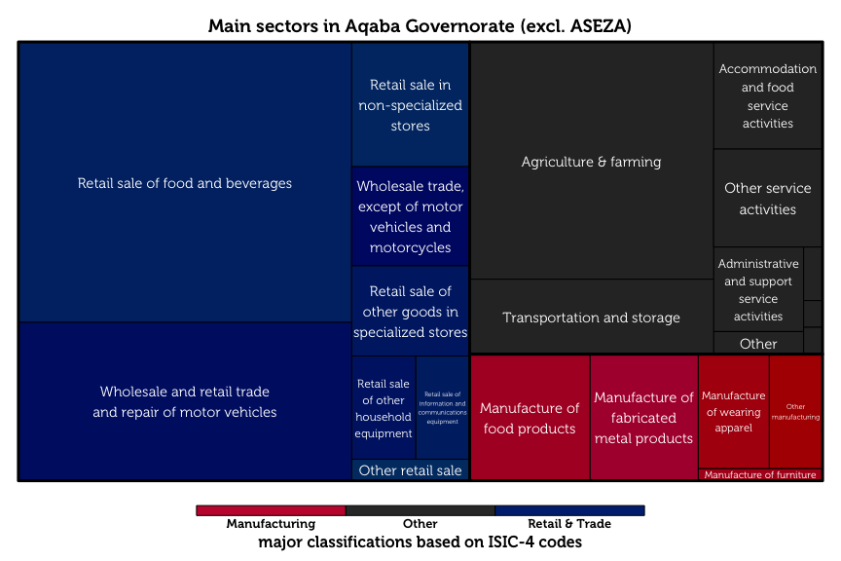The tree map diagram above shows the relative sizes of each business category, as classified by ISIC-4 codes. Retail and trade dominates as the largest sector (56.2%), followed by manufacturing (12.6%).

## Respondent Characteristics

The typical MSE owner in Aqaba is a married, 42-year old man with secondary school as his highest level of education. 45.2% of these owners have families of moderate size (4–7 members). However, a much higher proportion of owners in Aqaba have large families (8–11 members), with at least double the proportion than those found in Amman, Irbid, Karak, and Zarqa. Male business owners are typically the primary earners of their household, in sharp contrast to woman MSE-owners, who are rarely the breadwinners for their families.

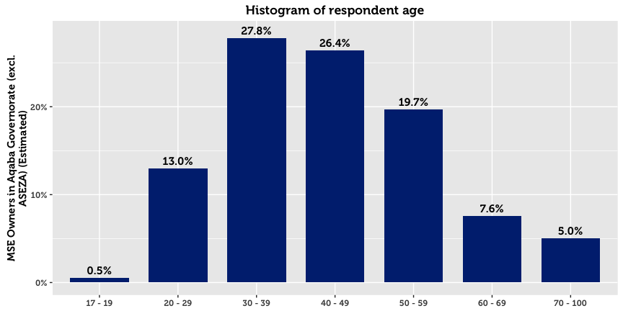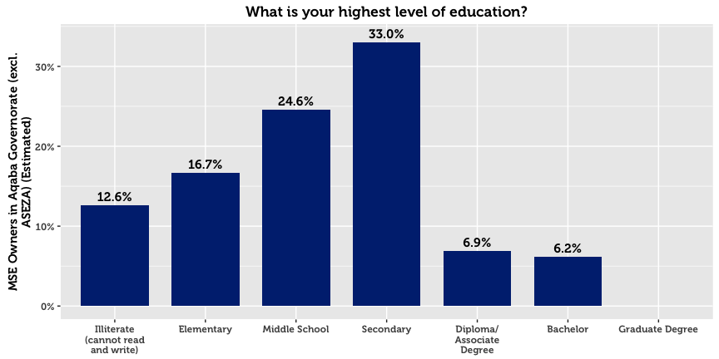

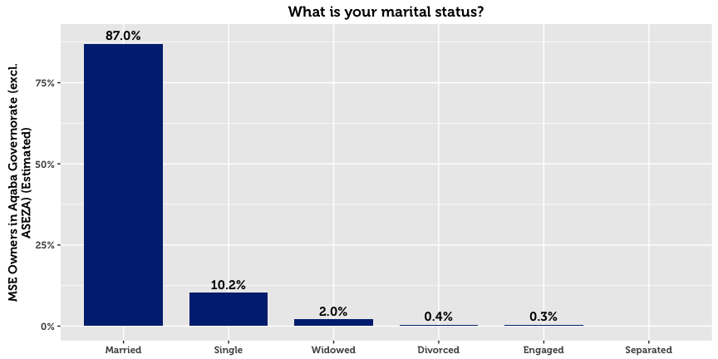

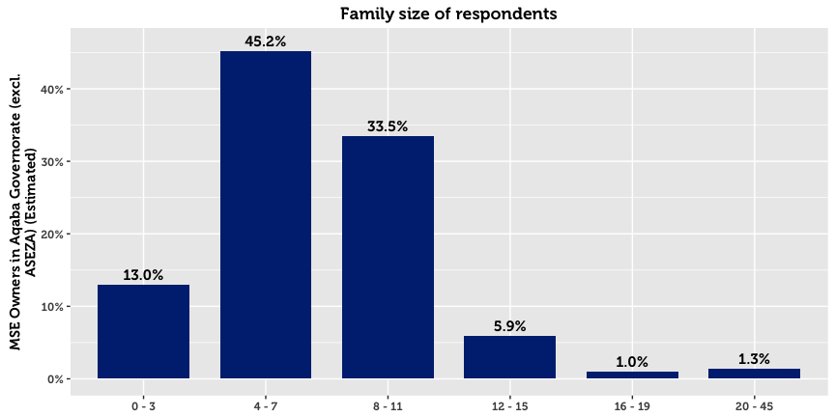

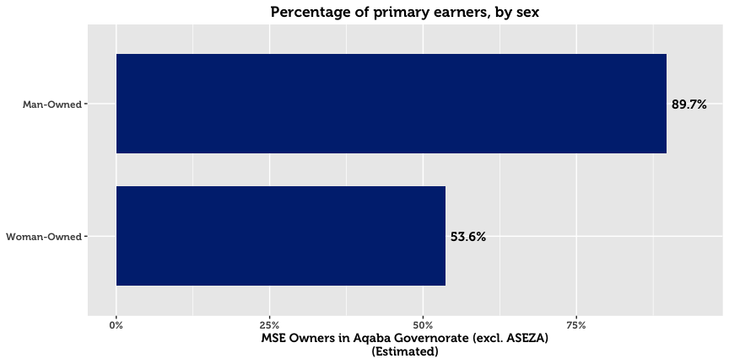

## Establishment, Registration & Business Continuity

The survey reveals that the typical MSE in Aqaba is one that was established in 2008[8]. Going back further in time, three quarters of MSEs that are registered in Aqaba were registered after 2002. 90.9% of the governorate’s establishments believe that they will continue with the business over the next three years.

A higher number of businesses are registered with the Ministry of Industry and Trade (MoIT) than anticipated. 50.4% of all MSEs in Aqaba are registered with the Ministry, a figure that is dramatically higher for man-owned businesses (54.1% for men compared to 9.7% for women). Registered businesses tend to be older than unregistered businesses by an average of two years.

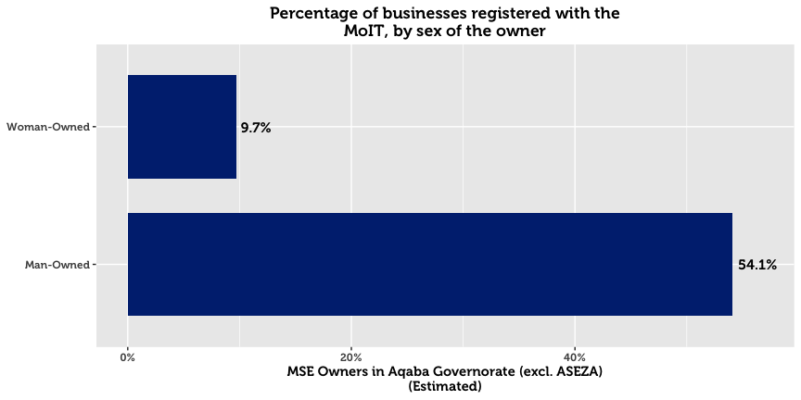

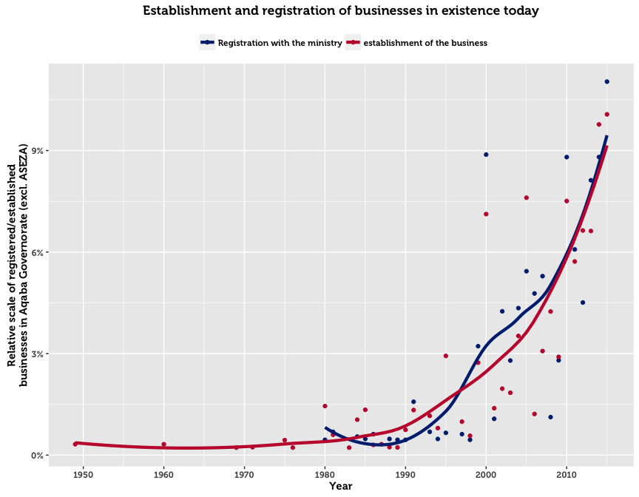

The above chart plots the frequency of business establishments and registrations by year. Almost all registered businesses were established and registered in the same year. The upward trend in registrations over time is most likely explained by three factors: (1) growth in the population of Jordan, (2) initiatives by the government to increase awareness and simplify the registration process, and (3) the fact that former establishments are not captured by the survey. The third reason implies that businesses that existed in the past but no longer operate become excluded from the sample. Such companies may have gone out of business for financial reasons, or ceased to exist due to the passing of the owner.

For those who chose to register, three main reasons emerge. The first reason is that registration is legally compulsory for their type of business (cited by 36.8%). The second is that MSE owners fear fines or harassment by police and authorities (cited by 36.6%). Thirdly, for the support available from the government once registered (21.7%). Availability of instance or official protection, access to finance, or the desire to export were not considered to be important primary motivations for business registration.

On the flip side, the dominant explanation given by half of the unregistered MSEs in Aqaba is that they see no benefits from officially registering their business (55.3%). 24.7% of MSEs who did not register responded with the category “Other” when asked for a reason, 55.3% responded that they were not registered because of a lack of incentive, and 11.0% because of cost.

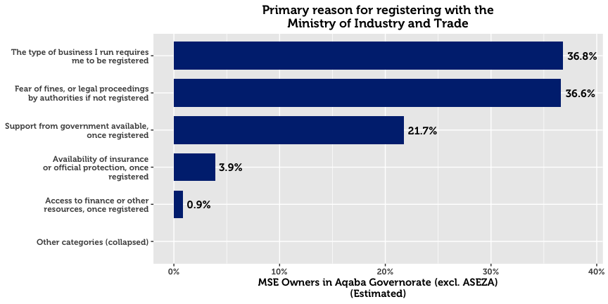

## 

## Seasonal Business

An estimated 82.9% of MSEs operate all year round. Woman-owned businesses, home-based businesses, and non-registered enterprises are more likely to be seasonal.

## Working Hours

61.5% of business owners work over the recommended 49 hours a week. This trend of long work hours is particularly pronounced for MSEs in retail sale of food, beverages and tobacco.

## Location of Conducting Business

In Aqaba, the majority of business is conducted from a fixed location outside of the home (79.4%). This primacy of fixed locations out of the home is consistent across sector and sex of the business owner. However, it is much less pronounced for woman-owned businesses, as men are 1.8 times as likely to operate out of a fixed location out of the home.

In stark comparison, 17.1% of MSEs are home-based.[9] Gender differences on this dimension are high: 52.8% of woman-owned businesses operate from their own home, compared to 13.9% for man-owned businesses. Certain industries are much more likely to be home based compared to other industries. These include animal production, manufacture of dairy products, retail sale in non-specialized stores, and pre-primary and primary education. It is noteworthy that most of these home-based businesses have specialized installations for their operations, suggesting that their enterprises are not merely casual and warrant capital investment.

In Aqaba, 2.9% of all businesses are run at changing place public spaces (such as markets). Although still a small number, this proportion is significantly higher than most other governorates. Those who participate in these changing locations are almost exclusively men.

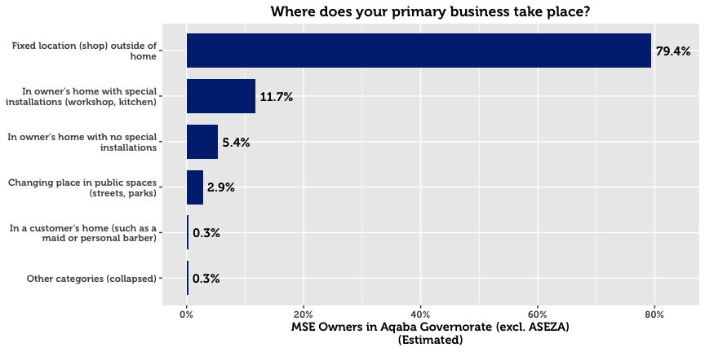

## Business Motivation

The main motivation for starting an MSE in Aqaba is to generate income for the owner’s family. 39.3% of owners cited this reason. An equally important motive is the desire to become a business leader (39.0%), followed by a desire to work in the industry (9.0%).

## 

## Conducting Other Business

30.6% of MSE owners in Aqaba have more than one business or income-generating project. In fact, of the governorates in the study, the southern ones are three times as likely as those of the north to have another business. Men are 3.8 times as likely as women to have another business.

## Legal Ownership of Business

82.2% of businesses in Aqaba are self-owned. 3.6% are owned by a male family member, and 2.9% by a male non-family member.

## Form of Incorporation

The majority of MSE owners who are formally registered exist as sole proprietorships (90.7%). Others are typically either General Partnerships (3.4%) or Limited Liability Companies (1.0%)

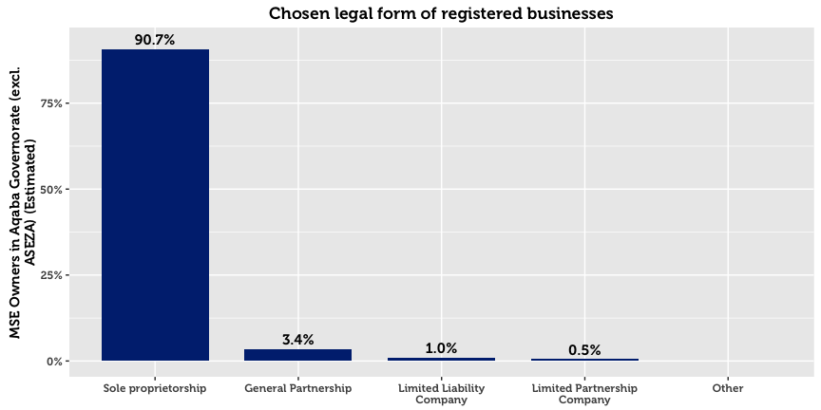

## Licensing

MSEs are by and large licensed with their municipalities. However, there exists a small subset that claim to be registered but not licensed (4.3%), and a subset that claim to be licensed but unregistered (6.1%). This may point to either a) misunderstanding of the question on behalf of the respondent, b) an expired license from the municipality, or c) an informal or illicit acquisition of a license from the municipality. As one might expect, home-based businesses have far higher chances of being unlicensed.

The two primary reasons cited my MSE owners for not being licensed are that they see no benefits to doing so (32.4%), and that it is not required for their business (23.7%). More than a quarter of respondents cited “other reasons,” perhaps due to reluctance to answer truthfully to a sensitive question.

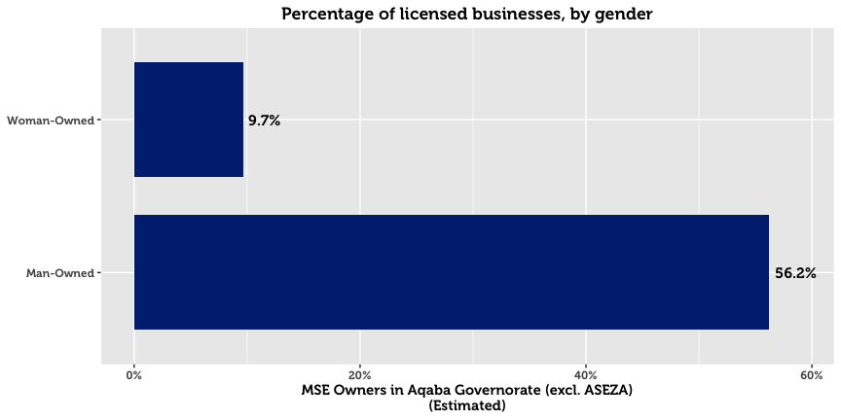

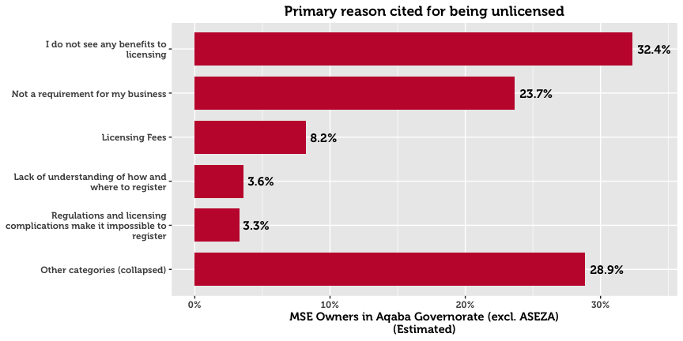

# Contracts

A large majority of surveyed enterprises never sign contracts: 90.3% of all MSEs. Only 4.4% report signing contracts either always or often. In the event of a dispute, 41.7% of MSE owners opt to take legal proceedings. 14.5% report that they will resort to doing nothing. 21.0% will resort to family intervention, and 3.1% will resort to an informal meeting.

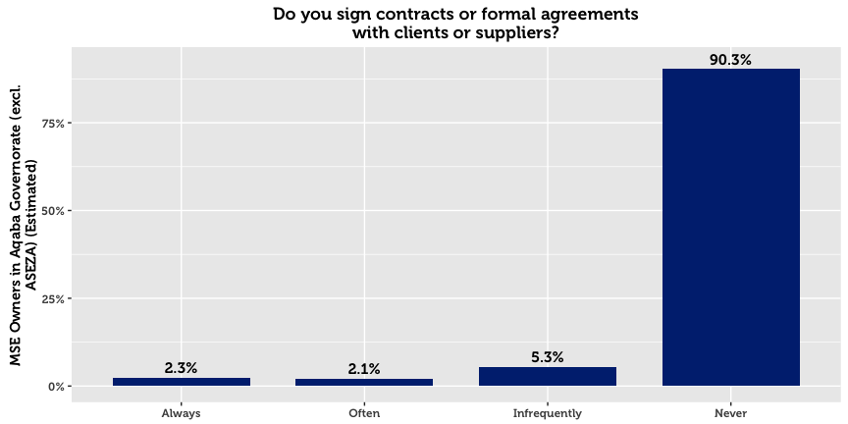

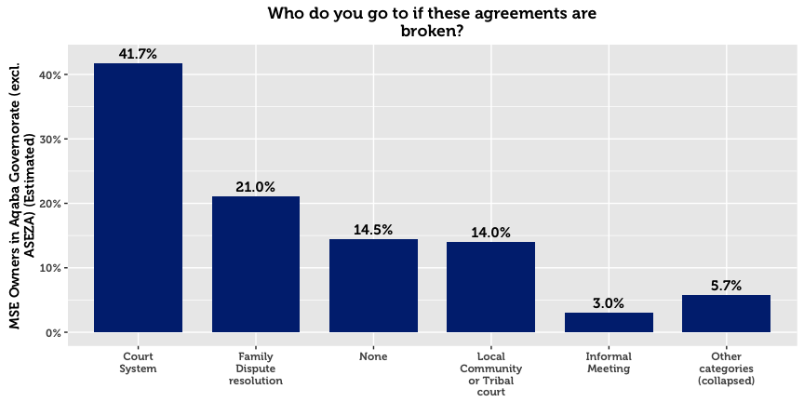

# Workforce

Only 12.0% of Aqaba’s MSEs hire employees—a far lower rate than any other governorate. Just 10.6% of Aqaba’s MSEs have full-time Jordanian staff, with more than half of those hiring only one employee. One explanation for this governorate difference might be that in Aqaba, there is a higher dependence on family for labor than formal employment in the governorate (the average family size is the highest in Aqaba, at 7.1). Only 2.0% of MSEs employ part-time workers, of which nearly half employ just one worker. Employment of women by MSEs is already rare in Jordan, but even more so in Aqaba. Not one full-time or part-time woman employee was identified in the entire governorate, despite the fact that the survey team attempted to contact every business in the area.

61.8% of MSEs with employees in Aqaba did not hire any new employees in the last year. 23.4% hired exactly one employee. No enterprises in Aqaba report employing workers below the age of 18.

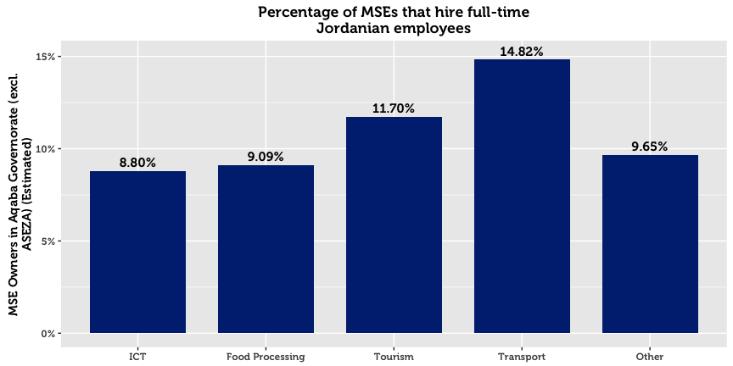

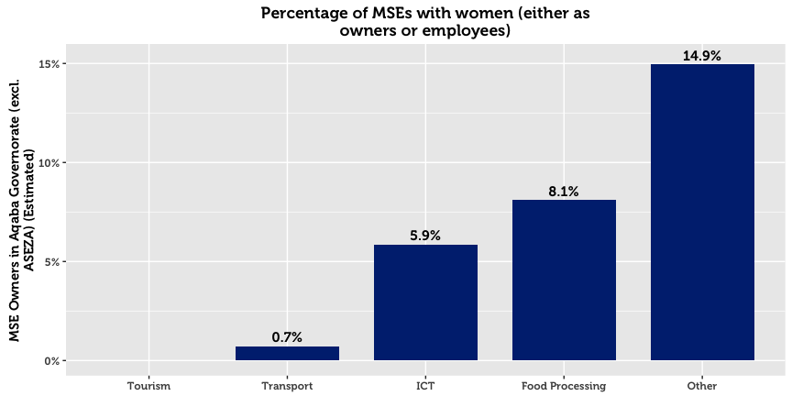

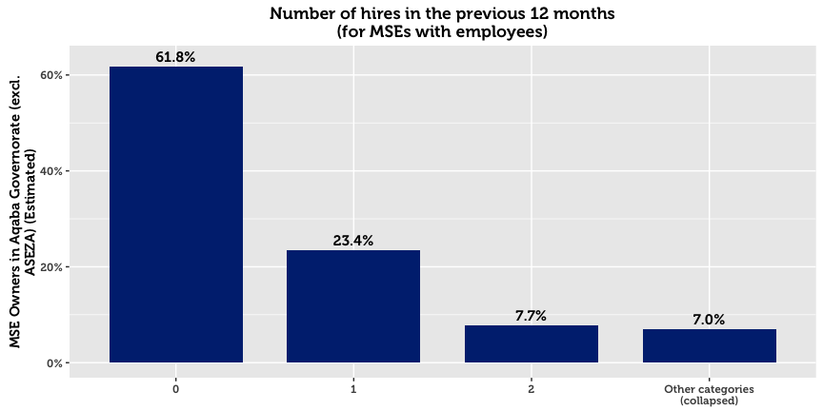

Nearly one in three enterprises hires 1 or 2 workers. Of those that hire workers, 82.8% say that none left their business during the previous 12 months. Of those that experience talent loss, the major attributions are personal reasons, social pressures, employees leaving to start their own business, salary demands, and unsuitable working hours.

|  |  |  |
| --- | --- | --- |
| **Primary Reason for Employee Loss (Aqaba)** |  | **All** |
|  |  | *N* = 15 |
| Personal Reasons |  | 49.5% |
| Social pressures meant they no longer wanted to work there |  | 14.3% |
| Employee left to start their own business |  | 13.2% |
| Working hours were not suitable |  | 12.6% |
| Employee’s salary demands were too high |  | 10.4% |

## Employee Training

Only 36.2% of MSEs with employees offer their workers in-house training. Those that did typically offered technical training, informal mentorship marketing assistance, or business management training. External trainings for employees are less common at 19.1%.

|  |  |  |  |  |
| --- | --- | --- | --- | --- |
| MSEs that Offer Employee Training* (Aqaba) |  | In-House |  | External |
|  |  | 36.2 %  *N* = 31 |  | 19.1%  *N* = 16 |
| Technical training/advice in your industry |  | 32.5% |  | 19.1% |
| Informal advice/mentorship |  | 28.1% |  | 16.4% |
| Marketing assistance/market information |  | 27.5% |  | 12.0% |
| Business Management Training |  | 27.2% |  | 17.2% |
| Recordkeeping |  | 21.1% |  | 14.7% |
| Human resources/soft skills training |  | 15.8% |  | 16.6% |
| Other |  | 21.0% |  | 10.2% |
| *\* Domain of analysis comprises only of companies with employees (86 total)* | | | | |

## External Assistance

It is estimated that only 4.7% of MSEs in Aqaba receive technical assistance.[10] A very small proportion receive assistance[11] from a private company (2.5%), a government program (2.3%), or through informal networks such as friends and family (2.3%).

# Firm Performance

69.9% of MSE owners report that they are either losing money or struggling to live comfortably. Only 28.8% of surveyed enterprises maintain that their business allows them to live comfortably, and 0.9% claim that their company allows them to live well above their living costs.

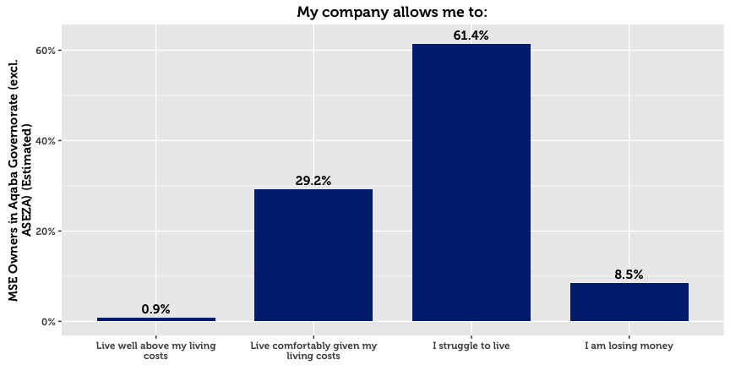

## Barriers to Economic Growth for MSEs

Although 76.0% of MSEs in Aqaba wish to expand their business, many of them face challenges in doing so. MSE owners were asked to state whether they agreed or disagreed that the following items represent barriers to the development their firms:

|  |  |  |  |  |  |
| --- | --- | --- | --- | --- | --- |
| **Barriers to Success (Aqaba)** |  | **All** |  | **By Sex of the Owner** | |
|  |  | *N* = 715 |  | Men | Women |
| Low demand |  | 62.8% |  | 63.3% | 57.2% |
| Low Purchasing Power |  | 58.0% |  | 57.2% | 66.9% |
| Price of inputs increased |  | 49.9% |  | 51.6% | 31.2% |
| Lack of financial support |  | 43.1% |  | 43.4% | 40.3% |
| Lack of appropriate suppliers |  | 39.6% |  | 41.4% | 20.6% |
| Lack of family support |  | 35.1% |  | 35.7% | 28.6% |
| Uncompetitive pricing of products |  | 32.6% |  | 32.4% | 34.8% |
| Unreliable transportation network |  | 29.1% |  | 31.0% | 8.0% |
| Cannot compete with quality of the products |  | 28.9% |  | 29.6% | 21.6% |
| Weak technical support or skills in this area |  | 28.7% |  | 30.0% | 14.3% |
| Lack of proper marketing skills |  | 25.2% |  | 26.2% | 14.3% |
| Lack of market information about the markets |  | 25.0% |  | 25.8% | 15.9% |
| Lack of human resource options |  | 25.0% |  | 26.5% | 8.0% |
| Lack of management skills |  | 22.7% |  | 24.1% | 8.0% |

The majority of firms believe that the major barriers are macroeconomic in nature. Low demand and low purchasing power top the list of barriers to success. Despite the fact that most MSEs lack many formal processes and mechanisms such as a bank account or trainings, most do not perceive this a major gap or barrier. Similarly to the other two southern governorates, more MSEs in Aqaba indicated that a lack of appropriate suppliers was a barrier to development compared to the governorates of the north (39.6% in Aqaba, compared to a combined average of 19.6% for the governorates of the north).

## Financial Performance

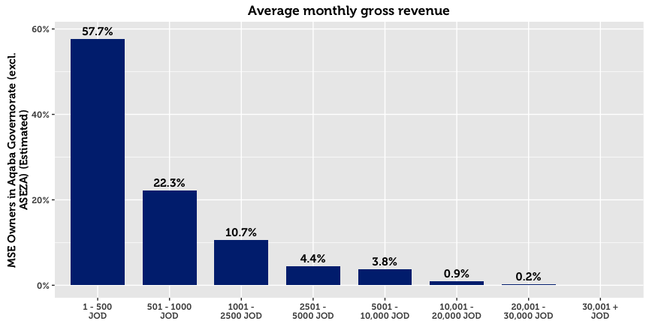

51.3% of MSEs in Aqaba report a monthly turnover of 500 JOD or less. However, 11.0% either refuse to disclose the exact amount, or do not know the amount. On average, non-registered enterprises, home-based businesses, and single-person MSEs report significantly lower gross revenue.

Profit is a more sensitive issue: Although 44.5% report finishing the previous month in the black, 1.3% refuse to disclose the exact amount, and 6.0% do not know the amount. Nevertheless, of those who make profit and are willing to share this information, the median profit is 200 JOD. The median amount of savings per month in Aqaba is 205 JOD.

|  |  |  |
| --- | --- | --- |
| 7.5%  Of MSEs in Aqaba make  monthly savings |  | 91.9%  Of MSEs in Aqaba make no  monthly savings |

# Access to Finance

Over half of micro and small enterprises in Aqaba generate enough money to sustain themselves without outside financing. Although many MSE owners struggle to live comfortably, as many as 14.0% say that they do not need a loan, though this is a lower proportion than in all other governorates. Accordingly, financial institutions do not play an economic role in the economic development of most MSEs, evidenced by the fact that only 8.2% of MSEs have applied for credit. In Aqaba, the most frequent reason is that MSEs find the financing conditions to be too difficult (18.1% cited this as the main reason). 16.7% of owners cite that they fear being unable to repay the loan. Being in the Middle East, religious reasons also matter, though ostensibly less in Aqaba than other governorates. Although the rise of Islamic Banking products has expanded the market, 13.3% of MSE owners cite religious prohibition as the main reason for not taking a loan.

The survey data suggests that MSE owners do not interact much with providers of credit, or even know about money markets. This is likely in view of the fact that only 7.5% of MSEs have bank accounts, that most loan applications get approved (72.2% reported approval), and that only 10.8% believe that they only have one source of credit to their disposition.

Approved loans are typically used for business purposes, primarily to upgrade products or business activities already being sold, to buy more resources (materials or goods), or to add new products or business activities. Only in limited cases is financing used to purchase property or to pay off company and personal debts.

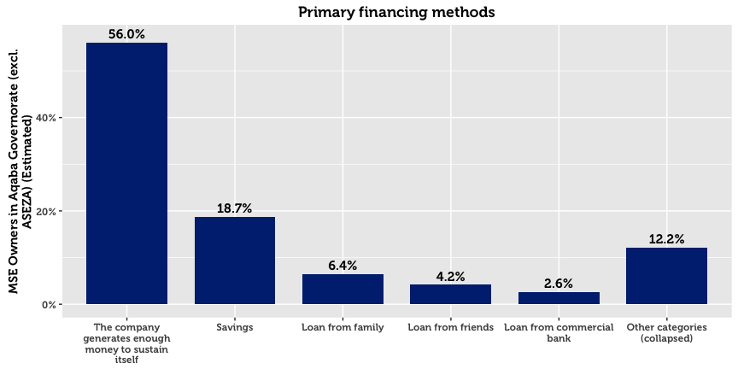

At 56.0%, self-financing operations are common in Aqaba. Less frequent models include financing through savings (18.7%) through family and friends (6.4% and 4.2%), or through commercial banks and microfinance institutions (2.6%).

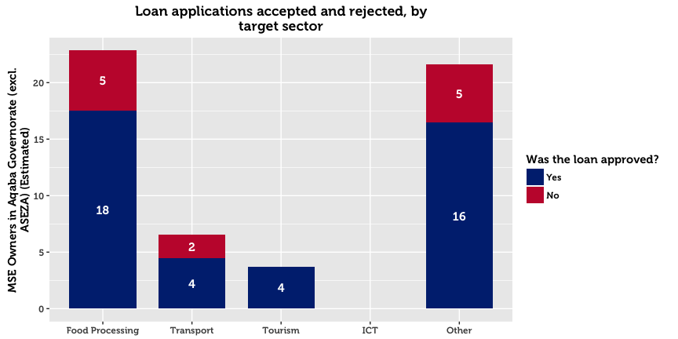

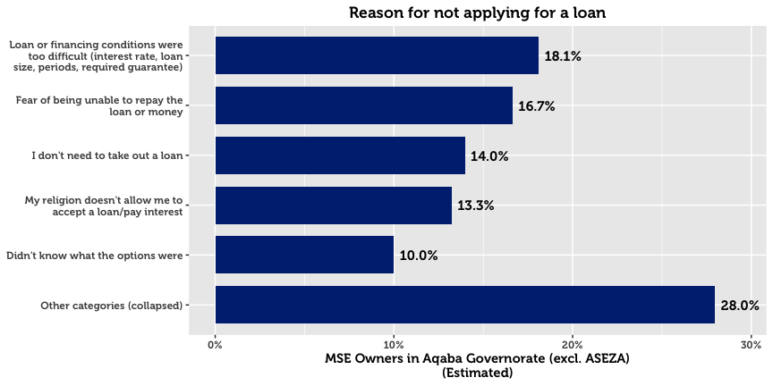

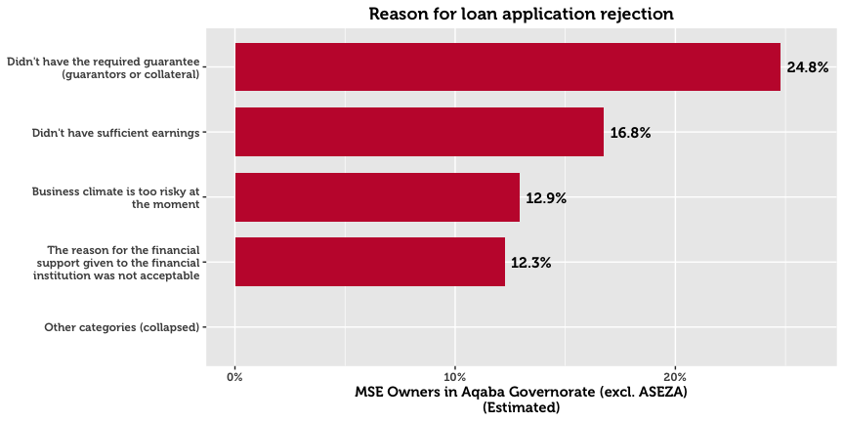

Of those who receive a loan, 40.7% receive it from a bank, and 38.9% from a microfinance institution. A less important source is international donors or donor-funded projects (6.9%). No MSEs in Aqaba report financing from government programs or private money lenders. When asked about the primary reasons for choosing a specific institution, 36.9% cite that their institution of choice offers the best financial prospects. 27.9% cite that they chose a particular provider because they are easy to understand and follow simple procedures.

Men and women differ greatly in the amount of money requested in loan applications. Whereas men request a median of 2,000 JOD, women MSE owners are far more conservative at 700 JOD. These differences may be confounded by the fact that the sex of the business owner is strongly associated with the subsector and location of the business.

# Systems, Processes and Networks

Online and offline use of computers within MSEs is minimal, at 4.2% of firms. Smart phones and ordinary mobile phones are used by 26.3% and 47.0% of MSEs respectively. Significantly fewer MSEs use vehicles than in other governorates (12.4%) such as Karak (22.6%) and Amman (27.8%). The differences are even more pronounced regarding use of smart phones (26.3%), which are used by 61.3% in Amman, and 67.5% in Zarqa.

|  |  |  |  |  |  |
| --- | --- | --- | --- | --- | --- |
| **Resource Use (Aqaba)** |  | **All** |  | **By Sex of the Owner** | |
|  |  | *N* = 715 |  | Men | Women |
| Mobile Phone |  | 47.0% |  | 47.4% | 42.9% |
| Smart Phone |  | 26.3% |  | 27.9% | 8.0% |
| Vehicle |  | 12.4% |  | 12.7% | 9.9% |
| Computer (with internet) |  | 4.0% |  | 4.4% | 0 % |
| Public Internet Location |  | 2.8% |  | 3.1% | 0 % |
| Email |  | 2.2% |  | 2.4% | 0 % |
| Computer (without internet) |  | 1.9% |  | 2.1% | 0 % |
| Social Media |  | 1.6% |  | 1.8% | 0 % |

Only 1.6% of MSEs use social media as part of business operations (4.7% for either work or personal). Naturally, this rate is more pronounced in the ICT sector, for which the digital environment is the main mode of work. The low number of social media users suggests that few MSEs understand social media, and that any target audience for social media is small. Email is even less ubiquitous, at 2.2%.

## Cooperation with Other Businesses[12]

In the previous 12 months, over three quarters of MSEs had often or always cooperated with other businesses in some capacity. The most frequent type of horizontal linkage was cooperating to purchase inputs, services, or equipment (65.6% cooperated often or always), followed by cooperation on market products or services (43.1%) and discussion (33.9%). Roughly one third worked with other businesses to transport goods to points of sale.

Other forms of cooperation were less common however, with most MSEs rarely or never cooperating on giving trainings or on receiving certifications (such as ISO, International Accreditation, First Aid etc.).

|  |  |  |
| --- | --- | --- |
| **Horizontal Linkages* (Aqaba)** |  | **All** |
|  |  | *N* = 715 |
| Purchase inputs, services, or equipment |  | 65.6% |
| Market products or services |  | 43.1% |
| Discuss information about the industry you are in |  | 33.9% |
| Transport goods to points of sale |  | 31.0% |
| Receive trainings |  | 25.4% |
| Other |  | 25.4% |
| Receive certifications |  | 18.2% |
| *\* captures owners who responded “often” or “always” for each form of cooperation* | | |

## Corruption

With respect to bribery, 90.7% of enterprises report that they have rarely or never been asked for an informal payment.

## 

## Financial Planning

The majority of businesses keep some form of financial records (66.0%). However, the vast majority of businesses record their finances on paper. A third of businesses keep no financial records whatsoever. A further indication of the lack of planning and financial organization is that only 38.5% compare their business performance against financial goals.

## Memberships & Access to Networks

For the most part, MSEs in Aqaba are not part of associations. With the exception of the Chambers of Commerce and Industry (for which 19.2% and 15.7% of MSEs were members), no association garners more than 10% of of the MSEs in the governorate. These categories include professional or trade associations (9.4%), cooperatives (6.7%), informal savings or loan groups (2.3%), women’s groups (1.9%), village committees (1.7%), youth groups (1.3%), microfinance groups (1.2%), and NGOs (0.4%).

Despite the fact that few participate in formal networks, 69.7% believe they can get a meeting with the mayor. This is lower for woman-owned businesses (54.4%).

|  |  |  |  |  |  |
| --- | --- | --- | --- | --- | --- |
| **Memberships (Aqaba)** |  | **All** |  | **By Sex of the Owner** | |
|  |  | *N* = 715 |  | Men | Women |
| Chamber of Commerce |  | 19.2% |  | 20.7% | 2.7% |
| Chamber of Industry |  | 15.7% |  | 16.9% | 2.7% |
| Formal trade, business, or professional association |  | 9.4% |  | 10.0% | 2.7% |
| Cooperative |  | 6.7% |  | 7.0% | 2.7% |
| Informal savings or loan group |  | 2.3% |  | 2.5% | 0.0% |
| Women’s group |  | 1.9% |  | 1.6% | 5.3% |
| Ward or village committee |  | 1.7% |  | 1.9% | 0.0% |
| Youth group |  | 1.3% |  | 1.4% | 0.0% |
| Microfinance group |  | 1.2% |  | 0.8% | 5.3% |
| NGO |  | 0.4% |  | 0.5% | 0.0% |

# Policy and Regulations

67.6% of MSE owners in Aqaba believe they know about the laws and regulations that govern their firm. As ‘digital literacy’ is relatively low, two thirds resort to traditional sources of information. In particular, MSE owners go to their municipality, friends and family, or lawyer for information. In Aqaba, considerably more rely on friends and family than in other governorates, and only 4.0% resort to government websites. 6.9% feel they have no use for this information.

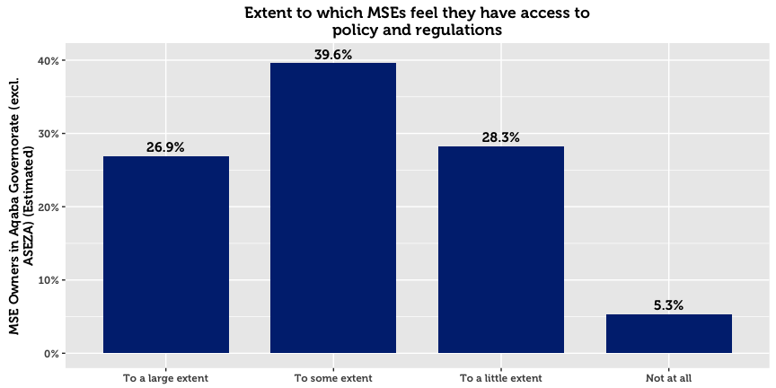

|  |  |  |  |  |  |
| --- | --- | --- | --- | --- | --- |
| **Policy Sources (Aqaba)** |  | **All** |  | **By Sex of the Owner** | |
|  |  | *N* = 715 |  | Men | Women |
| Family and friends |  | 43.4% |  | 41.9% | 61.7% |
| Local municipality |  | 28.4% |  | 30.0% | 9.7% |
| Lawyer |  | 9.0% |  | 9.4% | 5.3% |
| No use for this information |  | 6.9% |  | 6.6% | 10.0% |
| Do not know |  | 4.0% |  | 3.8% | 7.1% |
| Government website |  | 2.6% |  | 2.9% | 0.0% |
| Business support center |  | 0.6% |  | 0.7% | 0.0% |
| Local businesses and enterprises |  | 0.2% |  | 0.2% | 0.0% |
| Refused to answer |  | 0.0% |  | 0.0% | 0.0% |
| Other |  | 4.6% |  | 4.5% | 6.2% |

1. In this paper, micro- and small-enterprises are categorized in accordance with USAID LENS’ definition. A business (formal or otherwise) having fewer than 10 full-time employees (excluding the owner) is classified as a microenterprise, whereas businesses with 10 to 49 full-time employees, are categorized as small.
2. Throughout this paper, the area of “Amman” refers to the geographic area of Amman governorate, excluding the Greater Amman Municipality (“GAM”) which was excluded from the study. The area of “Aqaba” refers to the Aqaba Governorate, excluding the Aqaba Special Economic Zone (“ASEZA”).
3. Although results are representative of MSEs within each geographic area, results cannot be disaggregated on a more granular geographic level without compromising on acceptable sampling error rates. This is due to the clustering design in the first phase.
4. This total represents an estimate for the total number of MSE owners, without accounting for multiple-ownership. The survey reveals that 30.6% of business owners in Aqaba have a second business. The total number of MSEs is therefore higher than the total number of MSE owners. Throughout this report, we relax this strict distinction and commonly use language such as “X% of MSEs…” when referring to data about MSE owners.
5. In this report, “Population Estimate” means the absolute number of MSE owners in Aqaba, estimated using inclusion probabilities from the random sample. This statistical definition of “population” is not the same as the general understanding of the word in everyday language, which refers to the total number of people living within the boundaries of a nation state. Although many statistical publications use or when referring to these estimates, in this report we use the more intuitive notation *N* to denote population estimates, and *n* to denote unweighted sample counts.
6. Four sectors are examined throughout this report: Tourism, ICT, Transport, and Food Processing. These groupings are created on the basis ISIC-4 classifications collected in the survey, and are the primary data to reflect the four target sectors used for interventions in the LENS project.
7. Due to the large number of ISIC categories and the relative infrequency of most of them in the observed data, the search procedure for finding sectors of interest is conducted through statistical learning techniques, validated through resampling. This allows for most spurious relationships to be rejected.
8. Due to the high skew in the data, the median value (2008) is a more representative measure in comparison to the mean (2007).
9. In this report, a home-based business is any enterprise or income-generating project that operates from the owner’s home. As a result, this definition does not include MSEs operating in the homes of clients (maids, personal care, etc.).
10. Due to an error in the tablet software used for interviews, questions concerning technical assistance were only posed to MSE owners with employees.
11. Understood as financial or resource contributions from an international or local agency
12. Questions on cooperation with other businesses were only asked to SME owners in Aqaba, Karak, and Tafilah.